Reproducible Machine Learning Pipeline Using Dagster
Objective
The objective of this assignment was to design and implement a reproducible machine learning pipeline using Dagster, addressing common limitations of traditional Jupyter notebook–based workflows. The pipeline ensures reliable execution by explicitly tracking data dependencies, enabling partial re-execution, and maintaining reproducibility across multiple runs without rerunning the entire workflow.

Dataset
The Wine dataset from scikit-learn was used for this project. The dataset consists of numerical features derived from chemical analysis of wines and a multiclass target variable representing different wine categories. The structured and clean nature of the dataset makes it suitable for demonstrating reproducible machine learning pipelines and dependency-based execution.

Pipeline Design
The pipeline was implemented using Dagster’s asset-based architecture, where each logical stage of the machine learning workflow is modeled as an independent asset:
- raw_data: Loads the dataset and applies sampling-based preprocessing
- eda_summary: Generates descriptive statistics for exploratory data analysis
- train_test: Splits the dataset into training and testing subsets
- decision_tree: Trains a Decision Tree classifier
- random_forest: Trains a Random Forest classifier
- logistic_regression: Trains a Logistic Regression model
- knn: Trains a K-Nearest Neighbors classifier
Dagster automatically constructs a Directed Acyclic Graph (DAG) from these asset dependencies. The DAG clearly visualizes data lineage and execution order in the Dagster UI, improving transparency and debuggability.
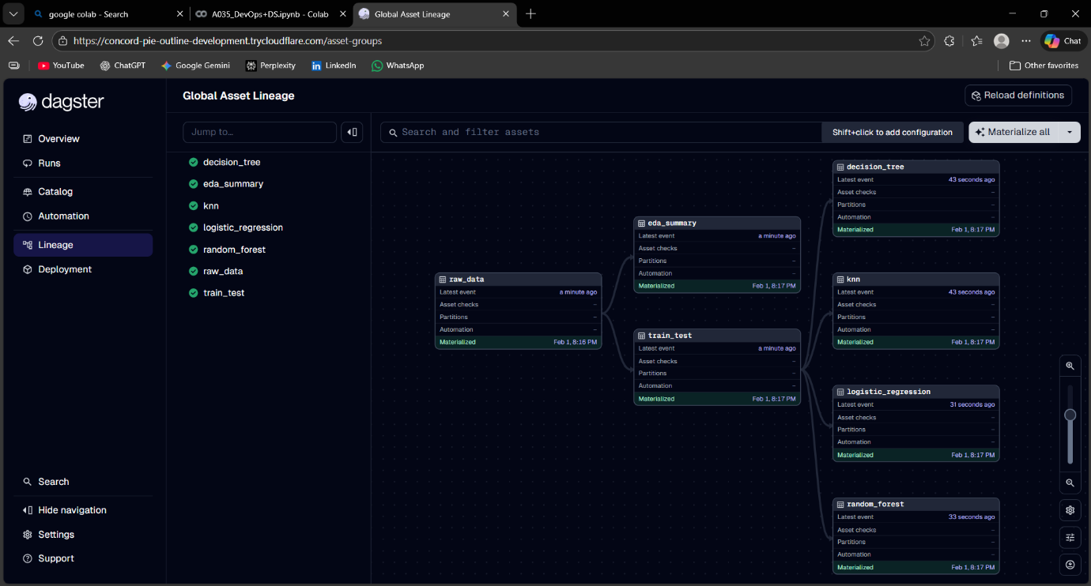
Execution and Reproducibility
The pipeline was executed using Dagster’s asset materialization commands. During the initial run, all assets were executed and their results were stored by Dagster. To demonstrate partial re-execution, a small change was introduced in the data-loading asset by modifying the sampling fraction.
When the pipeline was re-materialized, Dagster intelligently re-executed only the affected downstream assets while reusing previously materialized results for unaffected assets. This confirms that Dagster avoids redundant computation and ensures reproducible results without rerunning the full pipeline.
Performance Comparison
Approach | Approximate_Time
Rerunning entire notebook | ~25–30 seconds
Dagster partial re-run | ~18–22 seconds
This comparison highlights how Dagster reduces unnecessary recomputation by leveraging asset-level caching and dependency tracking, which becomes increasingly beneficial as pipeline complexity grows.

Results
All machine learning models were trained successfully, and accuracy metrics were produced for each model. Dagster tracked every execution run, asset materialization, and dependency relationship, providing a complete execution history. This ensures reproducibility, traceability, and auditability of the machine learning workflow.

Conclusion
Dagster provides a robust and production-ready solution for building reproducible machine learning pipelines. By enforcing explicit data dependencies and enabling partial re-execution, it significantly improves workflow reliability, reduces execution time, and eliminates common issues associated with rerunning Jupyter notebooks. This project demonstrates how Dagster can be effectively integrated into practical data science workflows.

GitHub Repository
The complete project, including the Dagster pipeline code and the Google Colab notebook, has been uploaded to GitHub for version control and reproducibility.
Link: - KritikaSharma2402/Dagster-Reproducible-ML-Pipeline: Reproducible ML pipeline using Dagster with partial re-execution

